Kol Simcha Torah Gazette
For parsha acharei mos-kedoshim 5785
Volume 9 Issue 32 (Whole #447) 12 Iyar 5785/ May 10, 2025
Printed L’illuy nishmas Nechama bas R’ Noach, a”h
For a free subscription, please forward your request to keren18@juno.com
Past emails can be found on the website ShabbosStories.com under Brooklyn Torah Gazette
The Rabbi and the Professor
By Rabbi Ari Kahn

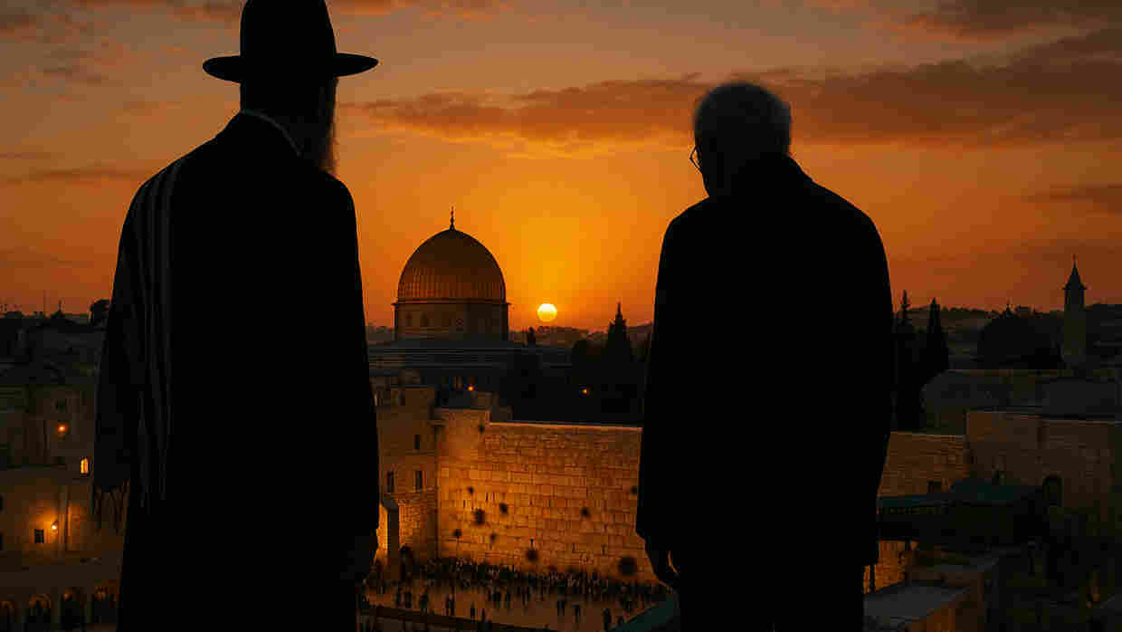

Many years ago, when I was a relatively young yeshiva student I had the opportunity to study with one of the great rabbis of the previous generation. His name was Rabbi Yisroel Zeev Gustman and he may have been one of the greatest rabbis of the 20th century. He was certainly the greatest "unknown" rabbi: While he fastidiously avoided the limelight and was therefore unfamiliar to the general public, he was well known to connoisseurs of Torah learning.
His meteoric rise from child prodigy to the exalted position of religious judge in the Rabbinical Court of Rabbi Chaim Ozer Grodzinski at around the age of 20 was the stuff of legend -- but nonetheless fact. Many years later, I heard Rav Gustman's own modest version of the events leading to this appointment: A singular (brilliant) insight which he shared with his fellow students was later repeated to the visiting Rav Chaim Ozer, who invited the young student to repeat this same insight the following day in his office in Vilna. Unbeknownst to Rav Gustman, the insight clinched an argument in a complex case that had been debated among the judges in Rav Chaim Ozer's court -- and allowed a woman to remarry.
One of the judges adjudicating the case in question, Rabbi Meir Bassin, made inquiries about this young man, and soon a marriage was arranged with his daughter Sarah. When Rabbi Bassin passed away before the wedding, Rabbi Gustman was tapped to take his place as rabbi of Shnipishok and to take his seat on the court. Although Rav Gustman claimed that he was simply "in the right place at the right time," it was clear that Rav Bassin and Rav Chaim Ozer had seen greatness in this young man.
While a long, productive career on the outskirts of Vilna could have been anticipated, Jewish life in and around Vilna was obliterated by World War II. Rav Gustman escaped, though not unscathed. He hid among corpses. He hid in caves. He hid in a pig pen. Somehow, he survived.

A Living Link to a Jewish World
Destroyed by the Nazis
For me, Rav Gustman was the living link to the Jewish world destroyed by the Nazis. I never had to wonder what a Rav in Vilna before the war looked like, for I had seen Rav Gustman, 35 years after the war. At the head of a small yeshiva in the Rechavia section of Jerusalem, Rav Gustman taught a small group of loyal students six days a week.
But on Thursdays at noon, the study hall would fill to capacity: Rabbis, intellectuals, religious court judges, a Supreme Court justice and various professors would join along with any and all who sought a high-level Talmud shiur (class) that offered a taste of what had been nearly destroyed. When Rav Gustman gave shiur, Vilna was once again alive and vibrant.
One of the regular participants was a professor at the Hebrew University, Robert J. (Yisrael) Aumann. Once a promising yeshiva student, he had eventually decided to pursue a career in academia, but made his weekly participation in Rav Gustman's shiur part of his schedule, along with many other more or less illustrious residents of Rechavia and Jerusalem.
The year was 1982. Once again, Israel was at war. Soldiers were mobilized reserve units activated. Among those called to duty was a Reserves soldier, a university student who made his living as a high school teacher: Shlomo Aumann, Professor Yisrael Aumann's son. On the eve of the 19th of Sivan, in particularly fierce combat, Shlomo fell in battle.

"They are all holy."
Rav Gustman mobilized his yeshiva: All of his students joined him in performing the mitzvah of burying the dead. At the cemetery, Rav Gustman was agitated: He surveyed the rows of graves of the young men, soldiers who died defending the Land. On the way back from the cemetery, Rav Gustman turned to another passenger in the car and said, "They are all holy." Another passenger questioned the rabbi: "Even the non-religious soldiers?" Rav Gustman replied: "Every single one of them." He then turned to the driver and said, "Take me to Professor Aumann's home."
The family had just returned from the cemetery and would now begin the week of shiva -- mourning for their son, brother, husband and father. (Shlomo was married and had one child. His widow, Shlomit, gave birth to their second daughter shortly after he was killed.)
Rav Gustman entered and asked to sit next to Professor Aumann, who said: "Rabbi, I so appreciate your coming to the cemetery, but now is time for you to return to your Yeshiva." Rav Gustman spoke, first in Yiddish and then in Hebrew, so that all those assembled would understand:
"I am sure that you don't know this, but I had a son named Meir. He was a beautiful child. He was taken from my arms and executed. I escaped. I later bartered my child's shoes so that we would have food, but I was never able to eat the food -- I gave it away to others. My Meir is a kadosh -- he is holy -- he and all the six million who perished are holy."

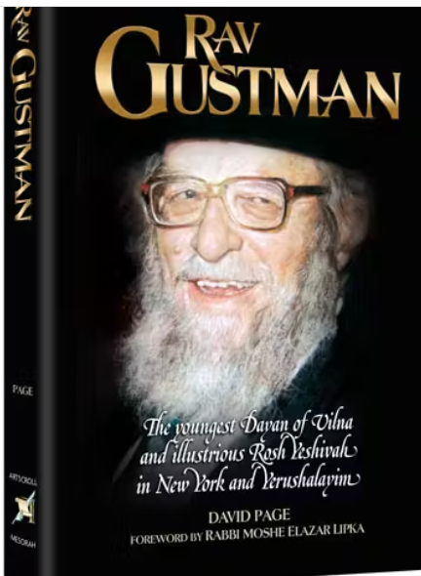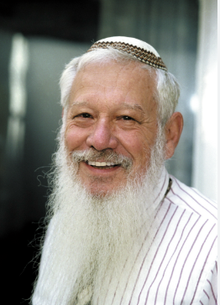
Rav Yisroel Zev Gustman and Professor Robert J Aumann

Rav Gustman then added: "I will tell you what is transpiring now in the World of Truth in Gan Eden -- in Heaven. My Meir is welcoming your Shlomo into the minyan and is saying to him ‘I died because I am a Jew -- but I wasn't able to save anyone else. But you -- Shlomo, you died defending the Jewish People and the Land of Israel.' My Meir is a kadosh, he is holy -- but your Shlomo is a Shaliach Zibbur – a Cantor in that holy, heavenly minyan."
Rav Gustman continued: "I never had the opportunity to sit shiva for my Meir; let me sit here with you just a little longer."
Professor Aumann replied, "I thought I could never be comforted, but Rebbi, you have comforted me."
Rav Gustman did not allow his painful memories to control his life. He found solace in his students, his daughter his grandchildren, and in every Jewish child. He and his wife would attend an annual parade (on Yom Yerushalayim) where children would march on Jerusalem in song and dance. A rabbi who happened upon them one year asked the Rabbi why he spent his valuable time in such a frivolous activity. Rav Gustman explained, "We who saw a generation of children die, will take pleasure in a generation of children who sing and dance in these streets."

"I think about those shoes every day of my life."
A student once implored Rav Gustman to share his memories of the ghetto and the war more publicly and more frequently. He asked him to tell people about his son, about his son's shoes, to which the Rav replied, "I can't, but I think about those shoes every day of my life. I see them every night before I go to sleep."
On the 28th of Sivan 5751 (1991), Rav Gustman passed away. Thousands marched through the streets of Jerusalem accompanying Rav Gustman on his final journey. As night fell on the 29th of Sivan, 9 years after Shlomo Aumann fell in battle, Rav Gustman was buried on the Mount of Olives. I am sure that upon entering Heaven he was reunited with his wife, his teachers and his son Meir. I am also sure that Shlomo Aumann and all the other holy soldiers who died defending the People and the Land of Israel were there to greet this extraordinary Rabbi.
On December 10th 2005, Professor Robert J. Aumann was awarded the Nobel Prize in economics. I am sure he took with him to Stockholm memories of his late wife Esther, and his son Shlomo. I suspect he also took memories of his Rabbi, Rav Gustman.
May it be the will of God that the People of Israel sanctify His Name by living lives of holiness which will serve as a light to the nations – and may no more children, soldiers or yeshiva students ever need to join that holy minyan in Heaven.

Postscript:
The last time I saw Rav Gustman, I was walking in the Meah Shearim/Geulah section of Jerusalem with my wife and oldest son who was being pushed in a stroller. It was Friday morning and we saw the Rosh Yeshiva, we said hello, wished him "Good Shabbes." Then I did something I rarely do: I asked him to bless my son. Rav Gustman looked at the toddler, smiled and said "May he be a boy like all the other boys."
At first, my wife and I were stunned; what kind of blessing was this? We expected a blessing that the boy grow to be a zaddik -- a righteous man -- or that he be a Talmid Chacham -- a Torah scholar. But no, he blessed him that he should be "like all the boys."
It took many years for this beautiful blessing to make sense to us. The blessing was that he should have a normal childhood, that he have a normal life, that he have his health... Looking back, I realize what a tremendous blessing Rav Gustman gave, and why.
Today, that son -- Matityahu, and our second son Hillel, are soldiers in combat units in the Israeli Defense Forces. Brave, strong, motivated and idealistic, they are wonderful soldiers, wonderful Jews. I pray that they return home safely along with all their comrades, and live normal lives -- "just like all the boys."

(Reprinted from the current website of aish.com This article is based on a combination of first-hand knowledge and a composite reconstruction of events as retold to me.)

******************************************************************************

You shall not curse the deaf (cheresh) (19:14) The word cheresh is an acronym standing for "chaim ra'im shelcha - your unfortunate life." The Torah warns us against cursing or imprecating ourselves when faced with a difficult situation. For as the Zohar explains, "There are three ways a person brings about his own adversity, one of which is by cursing himself." (Siftei Kohen)

And you shall love your fellow as yourself, I am G-d (19:18) True observance of the mitzva of Ahavat Yisrael, love for one's fellow Jew, requires a lot of effort. That is why the Torah follows the commandment with the words "I am G-d": G-d is ready and willing to help us perform this mitzva, if our desire is sincere. (Sefat Emet)

Reprinted from this week’s email of R’ Yedidye Hirtenfeld’s whY I Matter parsha sheet for the Young Israel of Midwood in Brooklyn.
Rav Avigdor Miller on
Unnecessary Suffering

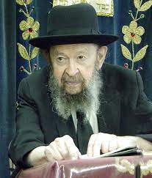
QUESTION: You spoke tonight about the benefits of suffering. If a person suffers from worrying about something, does this kind of suffering also have a beneficial effect?
ANSWER: Now let me tell you something. Hakodosh Boruch Hu supplies us with enough tests and trials without our creating them ourselves.
So, if somebody, chas v’shalom, is beset by worries that he didn’t create, he’s beset by illnesses that he didn’t create, then it’s a test from Hashem min haShomayim and it’s going to make him all the better for the fact that he’s able to live righteously despite his worries and despite his troubles.
But when somebody starts imagining things and he brings unreal worries upon himself or somebody is careless with his health and he brings artificially induced illness upon himself, he’s not going to get any reward for tests that he brought upon himself.
On the contrary, Hashem says, “I didn’t want you to suffer for nothing and you are making yourself suffer in vain; therefore, it’s a sin that you’re suffering.”
And therefore, any kind of self-induced suffering deserves no reward at all. Our job is to take care of ourselves because we have to treat ourselves like we treat our fellowman. Can you cause your fellowman suffering? It’s a sin. So, you shouldn’t cause this fellowman, yourself, any suffering either. And therefore, if you do, you get no reward. On the contrary, you’re held responsible for not taking care of that person who is your own ward, your charge – that’s your own body.
Reprinted from this week’s email of Toras Avigdor based on a Thursday night lecture delivered in October 1988.
The Sin of a Jew Rejecting this Physical World in Order to Come Closer to G-d
From the Teachings of the Lubavitcher Rebbe
Rabbi Menachem Mendel Schneerson, Zt”l

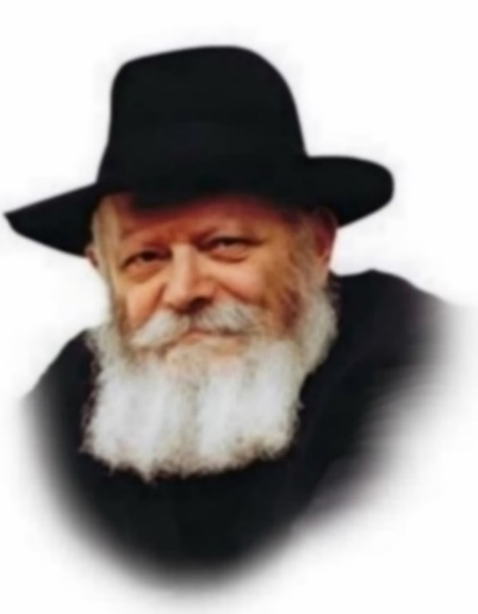

This week we read two Torah portions, Acharei and Kedoshim, the first of which begins: "And G-d spoke to Moses after the death of Aaron's two sons, when they approached before G-d, and they died."
Chasidut explains the reason Aaron's sons Nadav and Avihu died: The sons of Aaron did not commit a sin in the usual sense. In fact, they were extremely holy and righteous people, whose only desire was to draw closer to G-d. Their "sin," as it were, was that they allowed themselves to reach such a heightened state of devotion and yearning that their physical bodies became superfluous. In their desire to merge with G-d, their souls simply left their bodies and they expired.
Why was this considered a sin, given that a Jew is supposed to constantly strive to serve G-d by rising above the physical world? The answer is that alongside the spiritual quest for enlightenment and improvement, every Jew is obligated to make a "dwelling place for G-d in the lower worlds." That is to say, to serve G-d to the best of his ability within the context of his mundane, day-to-day life. In Judaism, the objective is to function as a soul within a physical body, rather than on a purely spiritual plane. This was the sin of Nadav and Avihu, who wished to serve G-d only with their souls.
Every story in the Torah contains a practical lesson for every single Jew. Even the story of Nadav and Avihu, which at first glance seems to apply only to Jews on the very highest spiritual level, i.e., those whose souls are "in danger" of departing their bodies out of longing for G-d, is relevant to all Jews, regardless of spiritual level.
The reason is that every Jew experiences certain times when his Jewish soul becomes aroused and elevated, and attains a higher and purer level. This is especially true during "auspicious times" such as Shabbat and Yom Tov, or Rosh Hashana and Yom Kippur, when every Jew "wakes up" and seeks to draw closer to G-d.
It is therefore most important that during these special times, when a Jew feels particularly close to G-d, he remembers that the ultimate purpose is to serve Him on the physical plane. Whenever a Jew feels spiritually aroused, he should immediately translate these feelings into actual deed, by resolving to strengthen his observance of Torah and mizvot. For the true goal of spiritual arousal is to positively influence our actions.

Reprinted from the Acharei Mos-Kedoshim 5762/2002 edition of L’Chaim. Adapted from Volume 3 of Likutei Sichot.

******************************************************************

And brings it not to the door of the Tent of Meeting, to offer an offering to the L-rd...blood shall be imputed to that man; he has shed blood, and that man shall be cut off from among his people (Lev. 17:4)
The main objective of the sacrificial offerings was to accustom the individual to mesirat nefesh, the concept of self-sacrifice. This self-sacrifice, however, must be directed in the proper way. Sacrificing oneself in the wrong place, i.e., for things that are outside the framework of Torah, is considered as bloodshed, pointless and without any benefit. (Eglei Tal)

Like the practice of the land of Egypt in which you dwelled do not do; and do not perform the practice of the land of Canaan... and do not follow their statutes (Lev. 18:3)
The Torah is not referring to specific prohibited practices, as these are explicitly forbidden in the coming verses. Rather, the warning refers to the way a Jew should conduct himself within the realm of the permissible. Even when eating and drinking, a Jew should take care not to imitate the ways of the nations; in all of his actions, it should be obvious that he is a Jew. (Sefat Emet)

Reprinted from the Acharei Mos-Kedoshim 5762/2002 edition of L’Chaim.
Rabbi Berel Wein on Parshat
Achrei Mos-Kedoshim 5785

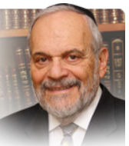

Usually, reaction to defeat and tragedy is the true defining moment of one’s inner strength and faith. Aharon’s silence in the face of the loss of his two older sons is reckoned in Jewish tradition as an act of nobility and sublime acceptance of the unfathomable judgment of Heaven.

Contrast Aharon’s silence and humble acceptance of fate with the response of Iyov to his troubles and tragedies. Iyov has a great deal to say, to complain against, to bitterly question and to debate almost endlessly with his companions and visitors as to the unfairness of what has befallen him. To the human eye, we are all aware that life and its events are often unfair.

There is no one that I am aware of that has successfully “explained” the Holocaust. So, it seems that we are faced with two diametrically opposed choices as to the proper response to mindless fate and tragedy. Are we to remain mute and silent or are we to rail against the arrogant fate that has brought misfortune to us?

The Torah does not seem to inform us about this and in fact, as shown above, apparently even contradicts itself regarding this continually recurring facet of human existence. Yet the Torah and all the books that it contains is one seamless whole, and the seeming contradictions lie within us and not within its holy words and exalted ideas. We are brought to study this matter with greater introspection and with less judgment and personal bias.

I think that the Torah means to teach us that there is no one correct, one-size-fits-all response to the failures and tragedies of life. Aharon is correct in his response to inexplicable tragedy and so is Iyov. King Solomon correctly noted that there is a time for silence and a time for speech. So too there are people for whom mute silence is the proper response to tragedy and there are people who must give expression to their feelings of grief and frustration by words, debate and even complaint. In most instances the rabbis of the Talmud voted for silence over speech and acceptance of one’s fate over complaint and public debate. Yet the rabbis did not exclude the book of Iyov from the biblical canon of holy books. In that act of inclusion, they allowed varying degrees of response to troubles and travail.

Iyov also has a place in the pantheon of heroic human views regarding tragic events. Within limits and with a faith-based attitude one can question and complain, express wonderment and even somehow demand answers. But, deep down, all humans understand that they cannot fathom Heaven’s wisdom, decisions and the individual fate that is visited upon us all. So, the death of Aharon’s sons serves as a template for life, a lesson for all of us.

Shabat shalom.

Reprinted from the current website of rabbiwein.com

******************************************************************

And Aaron shall offer his bull of the sin offering, which is for himself, and make an atonement for himself, and for his house (Lev. 16:6)
According to law, the kohen gadol (high priest) had to be married. Without a wife a man is considered incomplete, as it states in the holy Zohar: "A man without a woman is half a body." This degree of perfection is especially necessary in order to perform the service on Yom Kippur. (Tzohar Lateiva)

The nations of the world believe that holiness is incompatible with marriage; for this reason, their clergy refrain from marrying and are celibate. By contrast, in Judaism, the high priest, who embodied the highest levels of sanctity and merited to enter the holiest place on earth, was required to be married. If not, his service was invalid. (Taam Vadaat)

Reprinted from the Acharei Mos-Kedoshim 5762/2002 edition of L’Chaim

Rabbi Meir Mazuz, 80, Torchbearer
of Tunisian Torah and Tradition
By Motti Wilhelm

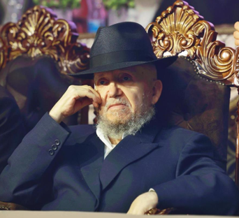
Rabbi Meir Mazuz

When discussing the exile of the Jewish people from the Holy Land, the Talmud¹ states, “The Holy One, Blessed be He, performed a charitable deed toward Israel in that He scattered them among the nations.” Commentaries explore the meaning of this statement and how exile can be seen as an act of kindness. One explanation is that through exile, the Jewish people are able to uncover and elevate the sparks of G-dliness hidden in each location.² This happens as Jews live in different places, absorb aspects of the surrounding culture into their Jewish practice, and incorporate elements of it into their Jewish life. Over time, this has created a beautiful tapestry of Jewish communities, each with its own unique practices and character, all contributing to the greater story of the Jewish people.
With the consolidation of Jewish populations into larger centers, much of this has been lost. Unique traditions, communal practices and special customs have, at times, blended into the broader fabric of Jewish observance. Yet there remain torchbearers who preserve these distinct heritages, ensuring they survive for generations to come.
Rabbi Meir Mazuz, who passed away on April 19, 2025—21 Nissan, the seventh day of Passover—was one such individual. A proud bearer of the Tunisian Jewish tradition, he hailed from a community that had thrived for millennia, and he carried forward its unique customs and distinctive approach to Torah study.
The founder of the Kisse Rahamim Yeshiva in Israel, a direct continuation of the yeshivah by that name that his father had established in Tunisia, Rabbi Mazuz taught generations of students in his distinctive style and led the network of schools across Israel that are associated with it. A renowned authority in Jewish law and the author of numerous Torah works, he was regarded as one of the foremost Torah scholars of his generation. His broad mastery extended to areas often overlooked, such as dikduk (Hebrew grammar) and piyyut (Jewish liturgical poetry).
In a statement released following the rabbi’s passing, Rabbi Yitzchak Yosef, the former Sephardic Chief Rabbi of Israel, eulogized him as “among the transmitters of tradition and the guardians of the ancient customs of his community, as well as the illustrious Sephardic heritage. He taught Torah to students for decades, meriting both to study and to spread Torah widely among the public. Sephardic Jewry will deeply miss a unique voice that is no longer with us.”

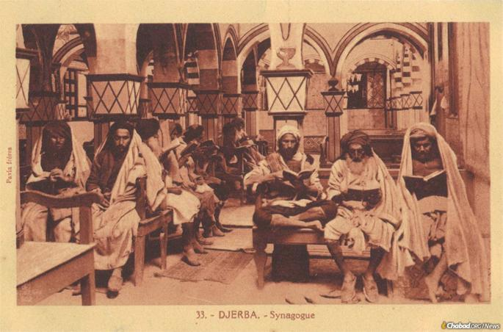
Jews pray in the ancient Djerba Synagogue in Tunisia.

Youth in Tunis
Meir Nissim Mazuz was born on the 13th of Nissan, 5705 (March 27, 1945) in Tunis, Tunisia, to his parents, Rabbi Matzliach and Kamsana Chana Mazuz. His father came from a long line of rabbinic figures in Tunisia’s rich Jewish history, which stretched back nearly two millennia. The elder Rabbi Mazuz served as a rabbinic judge and dean of a yeshivah in Tunis, and for a time even held a position as a judge on the Supreme Court of Tunisia.
As was customary at the time, Rabbi Matzliach Mazuz personally took charge of his son’s education, beginning by teaching him Torah. Along with the meaning of the texts, he also taught him the rules of biblical grammar and pronunciation, as well as the special melodies used for Torah reading in synagogues. From a young age, Meir’s brilliance and dedication to Torah study were evident, and he quickly became proficient in these areas. Recognizing his potential, his father soon enrolled him in an advanced yeshivah, where the other students were several years older, to begin studying Talmud and its commentaries.
In 1960, Jewish life in Tunisia, which had been steadily declining both materially and spiritually, received a much-needed boost. The Rebbe, Rabbi Menachem M. Schneerson, of righteous memory, dispatched Rabbi Nissan Pinson as his emissary to strengthen Jewish observance and help revitalize the community. Rabbi Pinson, who had previously served as a Chabad rabbi in Morocco, was determined to restore Jewish life, founding schools and yeshivahs to educate the next generation of Tunisian Jews.
Shortly after his arrival, Rabbi Pinson met Rabbi Matzliach Mazuz and gifted him a copy of the Tanya, the seminal work of Chabad teachings authored by the first Chabad Rebbe, Rabbi Schneur Zalman of Liadi. Young Meir Mazuz also studied from the Tanya and, decades later, recalled being “amazed” by the Rebbe’s editorial notes on his predecessor’s work, noting the Rebbe’s meticulous attention to each word and even the smallest details.³
Two years later, in 1962, Rabbi Pinson founded Yeshivas Oholei Yosef Yitzchak—named for the sixth Rebbe, Rabbi Yosef Yitzchak Schneersohn, of righteous memory—in Tunis. Both Rabbi Matzliach Mazuz and his son Meir began teaching at the yeshivah. Thus began a unique connection between the Mazuz family and the Lubavitch Rebbe, a bond built on deep mutual appreciation for Torah scholarship and communal leadership.
The following year, the elder Rabbi Mazuz established his own yeshivah, naming it Kisse Rahamim. Meanwhile, the younger Rabbi Mazuz continued teaching at Yeshivas Oholei Yosef Yitzchak for several more years, developing a close relationship with Rabbi Pinson. He frequently joined Rabbi Pinson at Chassidic farbrengens and assisted in Chabad’s outreach efforts. The Rebbe would later describe this period in Rabbi Mazuz’s life as a time when he was an “open Chabadnik.”⁴
Reflecting on those years, Rabbi Mazuz later wrote in 1982: “I will never forget the elevated and beautiful nights of Yud-Tes Kislev, Yud Shevat, or Yud-Beis Tammuz, celebrated at Chassidic farbrengens with Rabbi Pinson, may he live and be well, in Tunis.”
These dates commemorate major milestones in the lives of the Lubavitcher Rebbes—their releases from tsarist and Soviet imprisonment, and the anniversaries of their passing.
“In an atmosphere of spiritual elevation,” Mazuz wrote, “crowds of students and Torah scholars would sing with deep fervor: ‘Blessed is our G-d who created us for His glory,’ repeating again and again, with heartfelt devotion, the words: ‘and distinguished us from those who stray,’ like the roaring of the sea and its waves. Outside, wild and wandering youth, entranced by the charms of secularism, roamed the streets. But inside, there was warmth and light in the hearts.”⁵
In 1965, ahead of Rabbi Meir Mazuz’s marriage to his wife, Esther, his father sent a warm wedding invitation to the Rebbe, who responded with heartfelt blessings for the young couple.⁶ Three years passed, and they had not yet been blessed with children. At the time, Rabbi Mazuz was teaching at Oholei Yosef Yitzchak. The High Holidays were approaching and Rabbi Pinson was preparing to travel to New York to spend them in the Rebbe’s presence. Rabbi Mazuz asked Pinson to request from the Rebbe a blessing for children for him and his wife. “That very same month, our prayers were answered, and exactly nine months later, on the 26th of Sivan 5728 (1968), a son was born to me,” Rabbi Mazuz would recall in 1982.⁷

A Continuation in Israel
Terror struck the Mazuz family in 1971. On the morning of Jan. 18, while returning home from morning prayers, still wrapped in his tallis and wearing tefillin, Rabbi Matzliach Mazuz was assassinated by a Muslim terrorist. In the wake of the tragedy, his family emigrated to Israel, where his sons immediately set about reestablishing the yeshivah their father had founded.
The yeshivah would become more than just another center of Torah study in the Holy Land. It would stand as a lighthouse for Tunisian Jewry—illuminating their path in the sacred traditions of their community and ensuring that their rich legacy live on.
At the heart of its mission was a method of Talmudical study that Rabbi Mazuz termed Iyun Tunisa’i, the “Tunisian [approach to Talmudic] analysis.” This method emphasizes direct, forthright analysis, delving deeply into the words of the Sages to uncover their true intent. Rabbi Mazuz not only codified this approach in a written work but also taught tens of thousands of students to follow this path of learning.
The yeshivah also placed strong emphasis on biblical grammar—a field in which Rabbi Mazuz was recognized as a world-renowned expert—the practical application of Jewish law, and homiletics, equipping its graduates to serve as rabbis and leaders within their communities.
Opening a new yeshivah is always a difficult endeavor. It was especially so back then, when Israel’s economy was still struggling. Additionally, at the time the Sephardic community was an impoverished one, and there were very few Sephardic yeshivahs in existence at all. Though the path was fraught with challenges, Rabbi Mazuz persevered. What began as a small school in a rented space in Bnei Brak soon grew into a full-fledged institution with its own campus, eventually expanding into a comprehensive network of preschools, elementary schools, high schools, seminaries and yeshivahs, serving well over one thousand students.
He also stood at the helm of a rabbinic court, following in the footsteps of his father. In addition, Rabbi Mazuz founded a publishing company dedicated to printing the works of Sephardic Torah scholars, helping to preserve and promote their rich heritage.
Rabbi Mazuz also authored dozens of his own works, covering a vast range of subjects: Talmud, Jewish law, grammar, Jewish thought, philosophy and more. He was especially renowned as an expert in piyyut—the art of Jewish liturgical poetry. These intricate poems, composed by Jewish scholars over the centuries, weave together biblical verses, Hebrew and Aramaic poetry, and subtle references to people, ideas, and historical events. Properly understanding piyyut demands broad knowledge of Torah, history and Hebrew grammar—areas in which Rabbi Mazuz excelled. He published several works on piyyut and edited prayer books to ensure that these poems, which often became corrupted over time due to printer errors and unfamiliarity with their complexities, could once again be recited in their original, uncorrupted form.

A Miracle of Nine Dollars
In 1990, Rabbi Mazuz’s wife suffered a heart attack and was hospitalized, with doctors warning that she would likely remain unconscious. A yeshivah student close to Rabbi Mazuz approached the Lubavitcher Rebbe, who responded with a blessing for a speedy recovery. Indeed, she regained consciousness and was released from the hospital just two weeks later.
A few months later, Rabbi Mazuz traveled to New York, where he met the Rebbe in person for the first time. By that point, due to the large volume of people wishing to meet the Rebbe, he no longer held private audiences, but instead instituted what was known as “Sunday Dollars,” during which anyone could briefly meet the Rebbe and receive a dollar to give to charity. During his visit, Rabbi Mazuz participated in a “Sunday Dollars” and received the Rebbe’s blessings. But instead of a single dollar like most visitors, the Rebbe handed Rabbi Mazuz no fewer than $9. At the time, Rabbi Mazuz did not understand the significance of the number. Nine years later, when his wife passed away, he understood: The Rebbe had blessed her with nine additional years of life.

Caring for His Nation’s Well-Being
Rabbi Mazuz was deeply engaged in the practical concerns of Jewish life in Israel. Out of a profound sense of responsibility for the Jewish people and the Holy Land, he spoke out passionately for the integrity of the Land of Israel and stood alongside those who championed its cause.
In the final weeks of his life, Rabbi Mazuz’s health declined sharply, and he was hospitalized several times. Just before Passover, as his condition worsened, he told his students that he did not want to disrupt the joy of the upcoming holiday. True to his word, he held on for another week, passing away on the final day of the holiday.
He was mourned by Israel’s current and former chief rabbis, leading halachic authorities, prominent rabbis and members of the Israeli government.
“I deeply mourn, along with so many across our nation, the passing of Rabbi Meir Mazuz, of righteous memory—one of the great Torah scholars of our generation, head of Yeshivat Kisse Rahamim, and a pillar of Jewish law and Sephardic tradition,” wrote Israeli Prime Minister Benjamin Netanyahu. “I had the privilege of meeting and speaking with Rabbi Mazuz, and I was always deeply impressed by his wisdom, insight, and humility… I am confident that his unique spirit will be preserved for generations to come, and that the light of his Torah will never be extinguished.”
More than 150,000 people attended his funeral, where it was announced that Yeshivat Kisse Rahamim and its network of schools would be led by Rabbi Mazuz’s younger brother, Rabbi Tzemach Mazuz. In accordance with his will, no eulogies were delivered. Instead, three piyyutim—the sacred liturgical poems he loved so dearly—were sung by his many students, their voices rising together as a living testament to his legacy.
Footnotes
1. Pesachim 87b. 2. See Lubavitcher Rebbe, Ma’amar Poda B’shalom Nafshi 5732, in Toras Menachem, vol. 66 (Brooklyn: Lahak Hanachos, 2019), 258.
3. Rabbi Meir Mazuz, "Mesos Dor VaDor," Kfar Chabad Magazine, no. 65 (13 Elul 5742): 6. 4. Likutei Ma'anot Kodesh – Milu'im, vol. 2 (n.p., 2021), 102.
5. Mazuz, Mesos Dor VaDor, 7. 6. Teshura: Mazkeret Mi-Simchat Ha-Nissuin shel Shmuel u-Mnucha Rachel Sheyichyu Amar, Yud-Alef Elul 5782 (Brunoy, France), 53. 7. Mazuz, Mesos Dor VaDor, 7. 8. Yitzchak Yehuda, interview with Rabbi Meir Mazuz, in “HaRebbe Hu HaNesher HaGadol Shel Dorenu,” Kfar Chabad Magazine, no. 991, p. 62.

Reprinted from the current website of Chabad.Org
Market Day in the
Lower East Side

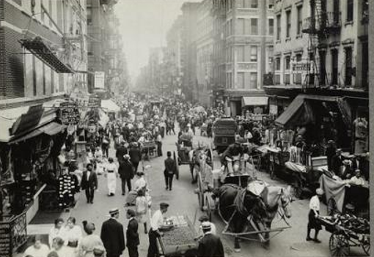
In this photograph, Lewis Wickes Hine (1874-1940) masterfully captures the vibrant life, dynamism, and exuberant spirit of the Lower East Side in 1912. Its atmosphere calls to mind the bustling market days in the Jewish towns in Eastern Europe, while the skyline of tenement houses and the pedestrians dressed in their Sunday best place the viewer in New York’s “Jewish quarter of East Side.”
The photograph offers a fascinating view down a long, unnamed busy street somewhere at the heart of the Lower East Side’s Jewish neighborhood. A seemingly endless row of shops lines both sides of the street, punctuated with pushcarts moving in different directions or stationed in the middle of the street, loaded with an array of wares ready to tempt some new Americans on a beautiful warm Sunday.
Hine indeed reveals the American life in the making, in the midst of the Lower East Side.
Reprinted from the Miriam and Ira D. Wallach Division of Art, Prints and Photographs from the New York Public Library.

